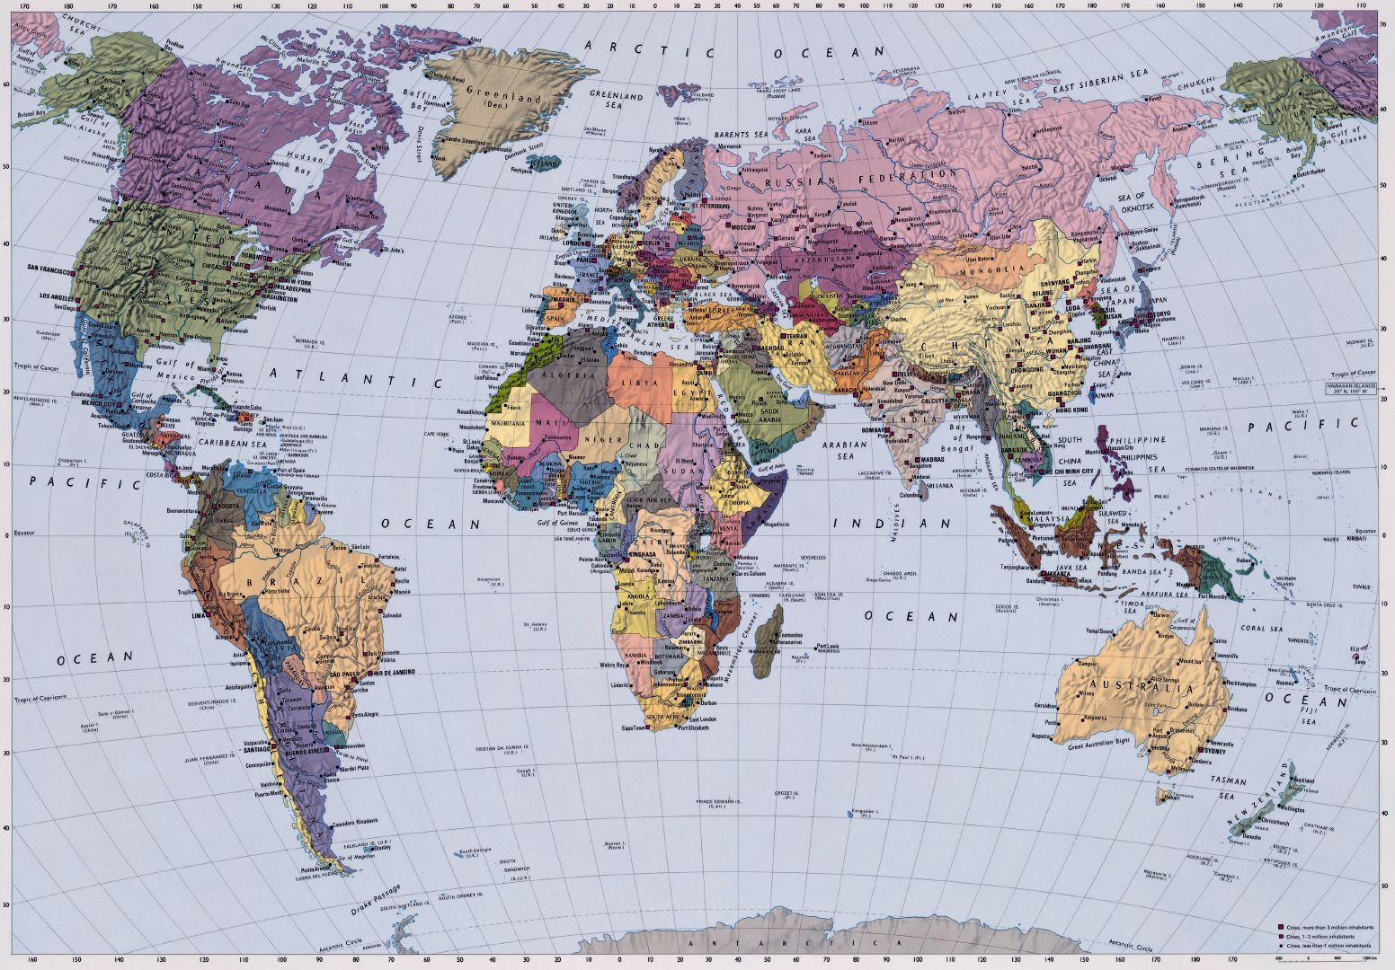

**Allen Sanderson Harper Lectures for University of Chicago Alumni Chapters**

Baltimore MD (2010); Bangalore India (2012); Boston MA (2010);

Chapel Hill NC (1995); Chicago (1995, 2005, 2010, 2015, 2016, 2017);

Cleveland OH (1995); Dallas TX (1995); Delhi India (2012); Denver CO (2007);

Detroit (2007); Hong Kong (2012); Houston TX (1995);

Indianapolis IN (2010); New York City (2014);

Northern New Jersey (2004); Paris France (2007);

Mexico City (2012); Mumbai India (2012); Philadelphia PA (2006);

Phoenix AZ (2005); Pittsburgh PA (2005); Portland OR (2005);

Saint Louis MO (2004); San Diego CA (2006); Seattle WA (2005);

Shanghai China (2012); Singapore (2012); Tampa FL (2010);

Toronto (1995); Vancouver (2005)

|  |
| --- |
|  |